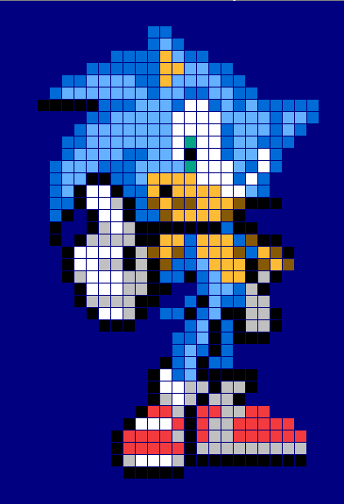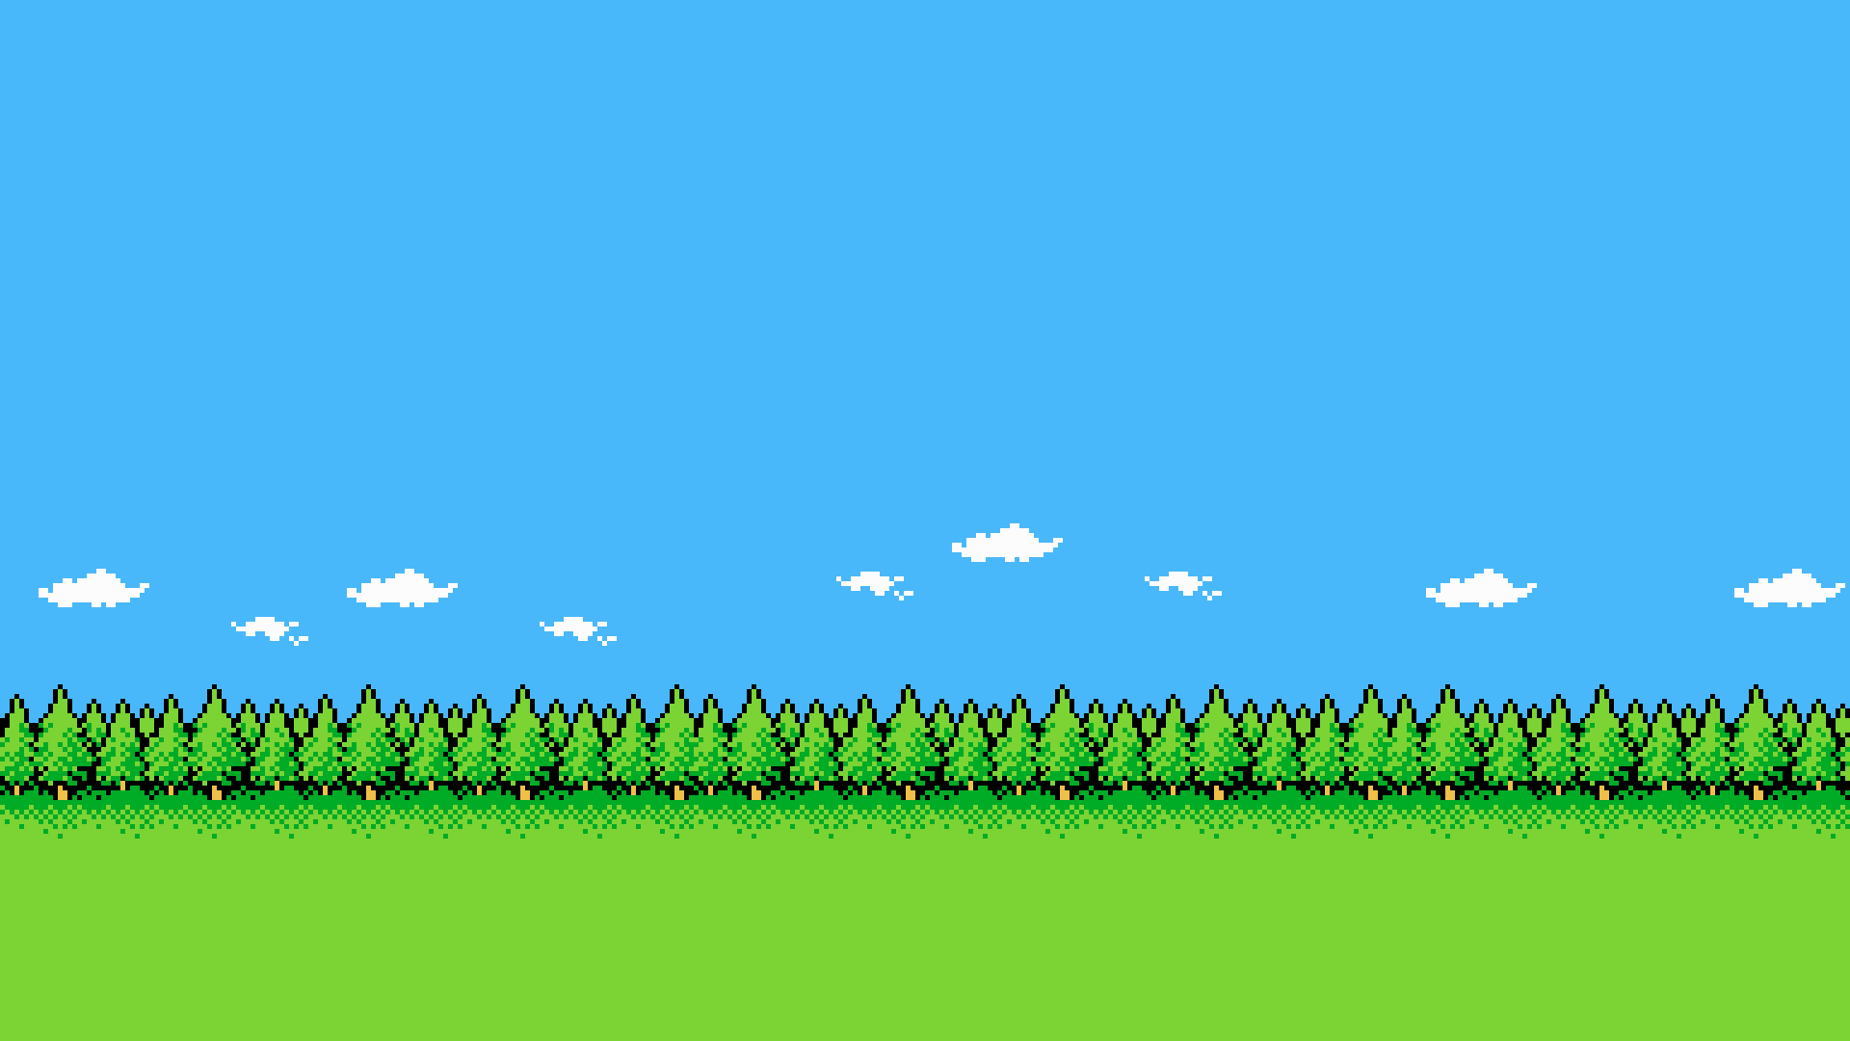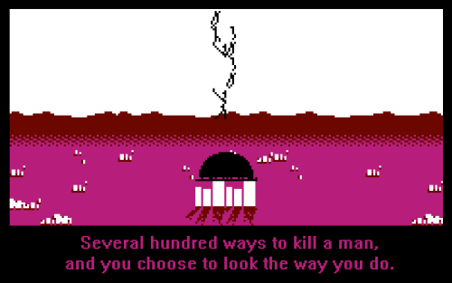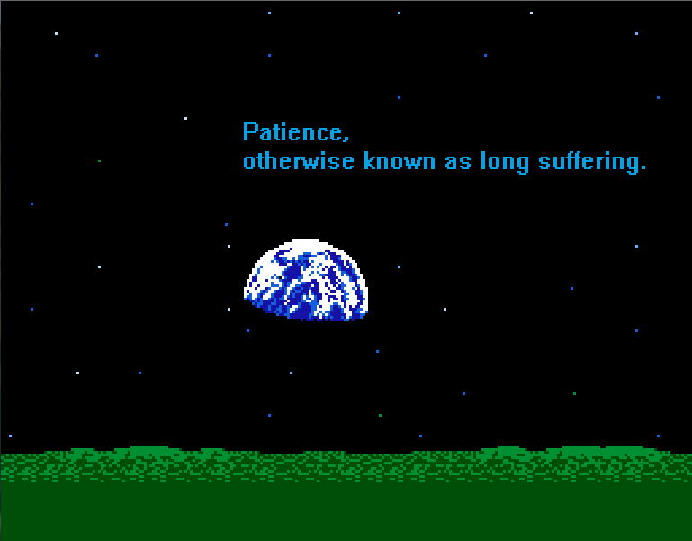

I firstly started to look through arrange of different images involving 8-bit pixel art form which enabled me to come up with a basic scene for our game.

i started to research into an old none digital game known as “water game” we have all played one of these as a child, I like how the background relates to being out at sea which involves water scenes. I was thinking about implementing this style into our game being drawn out as an 8-bit art form, but I cannot just go towards one Idea. Below there will be a range of different potential backgrounds.  
